Aim: - To write C++ code of the given following tasks.

Software Used: -

Cloud Keil Studio IDE and Tera Term

Theory: -

The mbed NXP LPC11U24 Microcontroller in particular is designed for prototyping low-cost USB devices, battery powered applications and 32-bit ARM® Cortex™-M0 based designs. It is packaged as a small DIP form-factor for prototyping with through-hole PCBs, stripboard and breadboard, and includes a built-in USB FLASH programmer.

Specifications of LPC11U24:

* NXP LPC11U24 MCU
* Low power ARM® Cortex™-M0 Core
* 48MHz, 8KB RAM, 32KB FLASH
* USB Device, 2xSPI, I2C, UART, 6xADC, GPIO
* Prototyping form-factor
* 40-pin 0.1" pitch DIP package, 54x26mm
* 5V USB, 4.5-9V supply or 2.4-3.3V battery
* Built-in USB drag 'n' drop FLASH programmer
* mbed.org Developer Website
* Lightweight Online Compiler
* High level C/C++ SDK
* Cookbook of published libraries and projects

API Used:

* Syntax used for digital output:
* DigitalOut (PinName pin)
* For LED blinking we’ve used:
* DigitalOut variable(LEDn); where n= 1,2,3,4
* For delay:
* wait(t); where ‘t’ is in seconds

Task 1: - Display hello world on the LCD.

Code: -

#include "mbed.h"

#include "TextLCD.h"

TextLCD lcd(PA_3,PA_2,PA_10,PB_3,PB_5,PB_4);//rs,e,d0,d1,d2,d3

int main()

{

    lcd.printf("20BLC1087");

}

Output: -

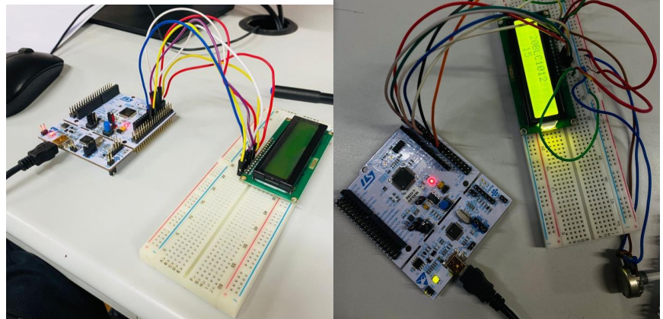 

Task 2: - Display continuous variable count on LCD 2nd row and 5th digit.

Code: -

#include "mbed.h"

#include "TextLCD.h"

TextLCD lcd(PA_3,PA_2,PA_10,PB_3,PB_5,PB_4);//rs,e,d0,d1,d2,d3

int main()

{

    for (int i=0;i<11;i++)

    {

        lcd.printf(i);

        int i=1;

        while (1)

        {

            lcd.locate(5,2);

            lcd.printf("%f",i);

            i=i+1;

        }

    }

}

Output: -

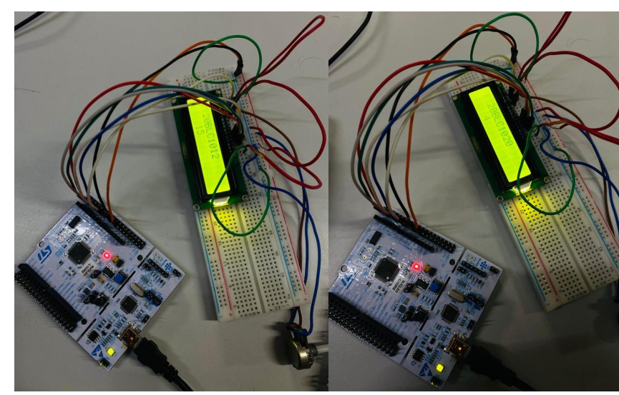

Verification Status: -

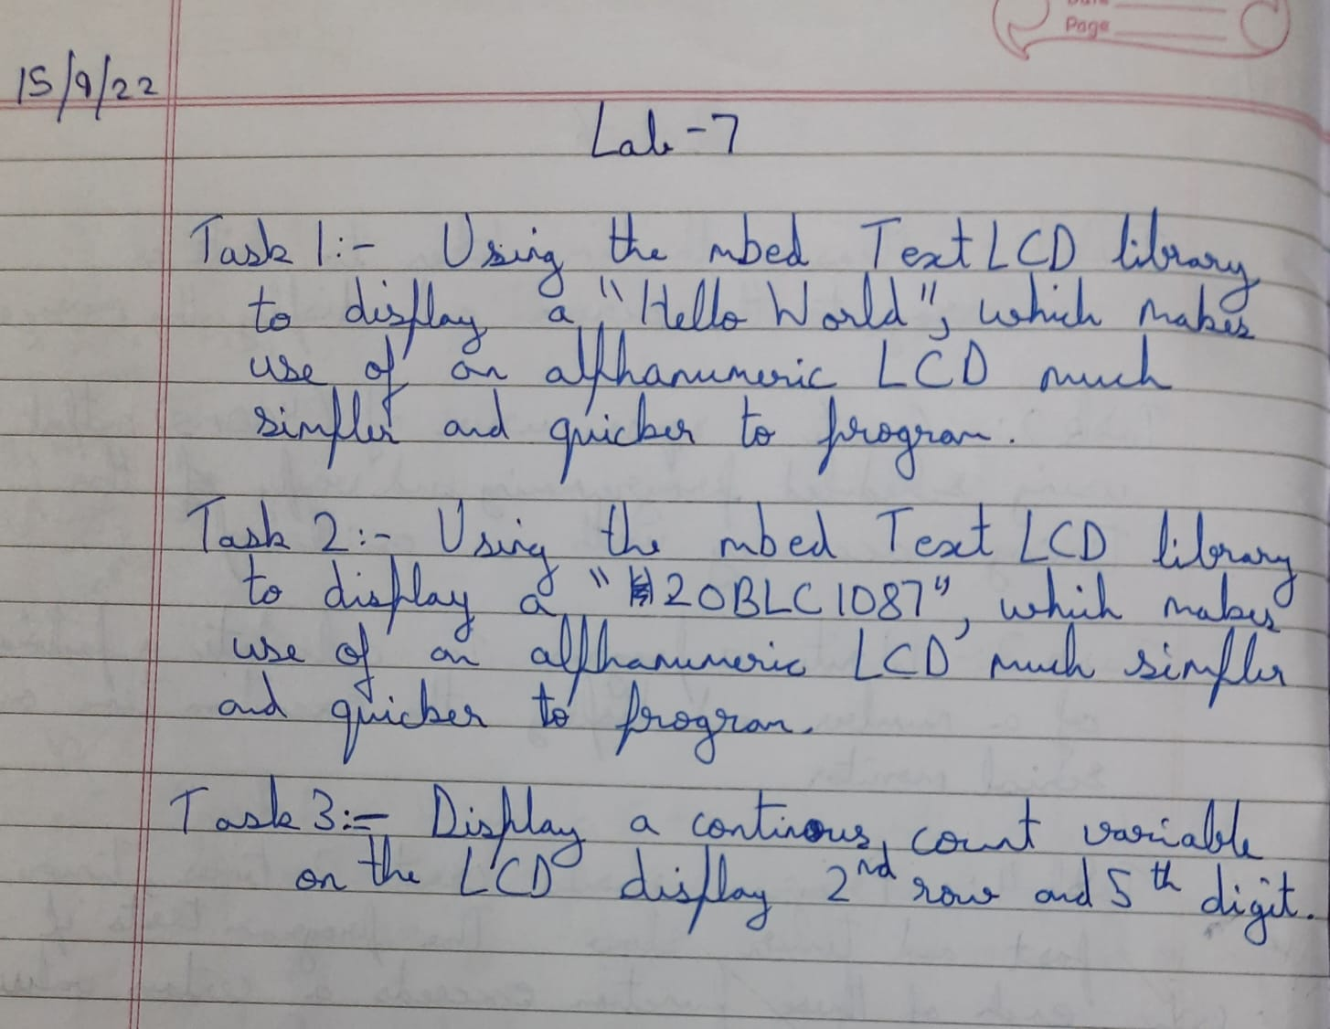

Result: -

Successfully understood and performed all the given tasks.